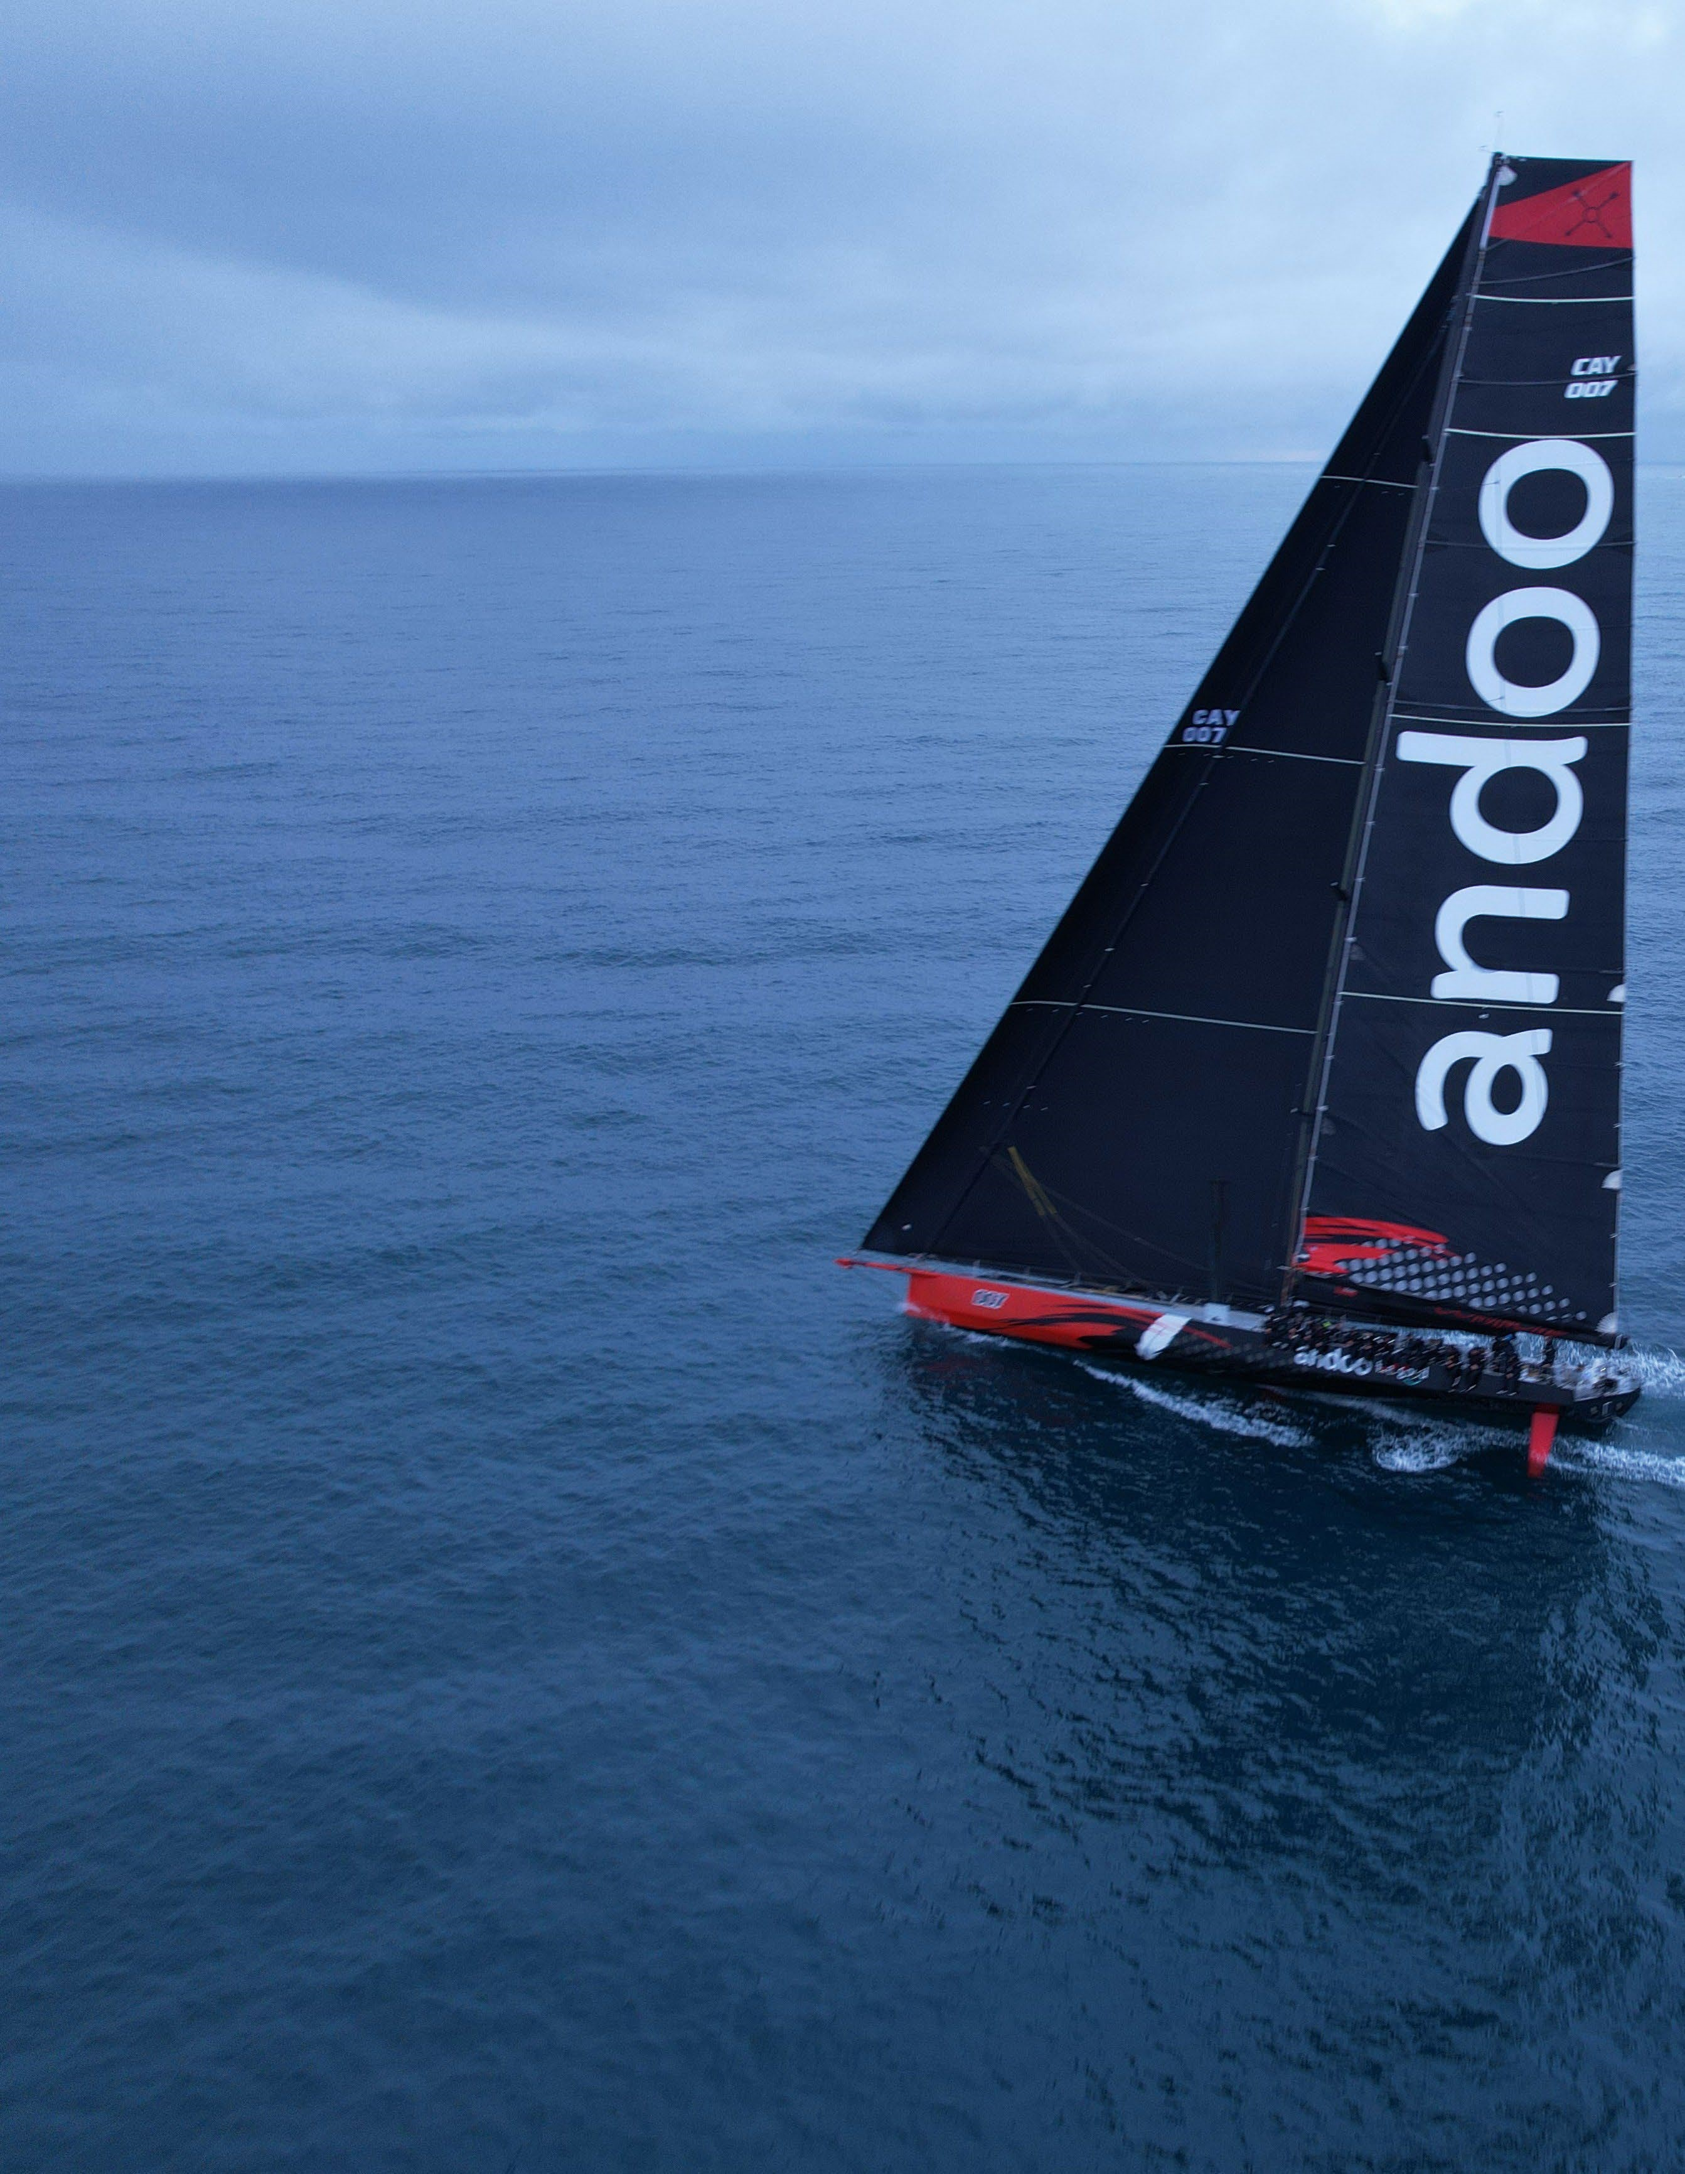

**NOAKES SYDNEY**

**GOLD COAST**

**YACHT RACE 2023**

NOTICE OF RACE

SYDNEY, AUSTRALIA

//

29

JULY

2023

The Maritimo Gold Coast Mackay Yacht Race 2024, will be conducted on the Tasman & Coral Sea’s along the Queensland coast line from Surfers Paradise to Mackay.

Owners and charterers of eligible boats are invited to enter on the conditions of this Notice of Race.

The race is organised and conducted by the Southport Yacht Club (“SYC” or the “Organising Authority”).

# 1. THE RACE

**1.1.** The race is a 520 nautical mile passage race.

**1.2.** The start of the race will be in the ocean waters at Surfers Paradise Queensland and the finish will be at Mackay, Queensland. Details of the course will be included in the Sailing Instructions.

**1.3.** The warning signal for the race will be signalled at 1250 hours (Australian Eastern Standard Time) on 1st August 2024, with the starting signal at 1300 hours.

# 2. RULES

## 2.1. General

The race will be governed by the rules, as defined in The Racing Rules of Sailing 2021-2024 (“RRS”) of World Sailing, including;

1. the IRC Rules 2024 Parts A, B and C;
2. the ORC Rating System Rules 2024;
3. the prescriptions and special regulations of Australian Sailing (“AS Special Regulations”).

## 2.2. Amendments

Amendments to this NoR will be published on the Official Notice Board. A notice of an amendment will also be sent to boats that have commenced the entry process.

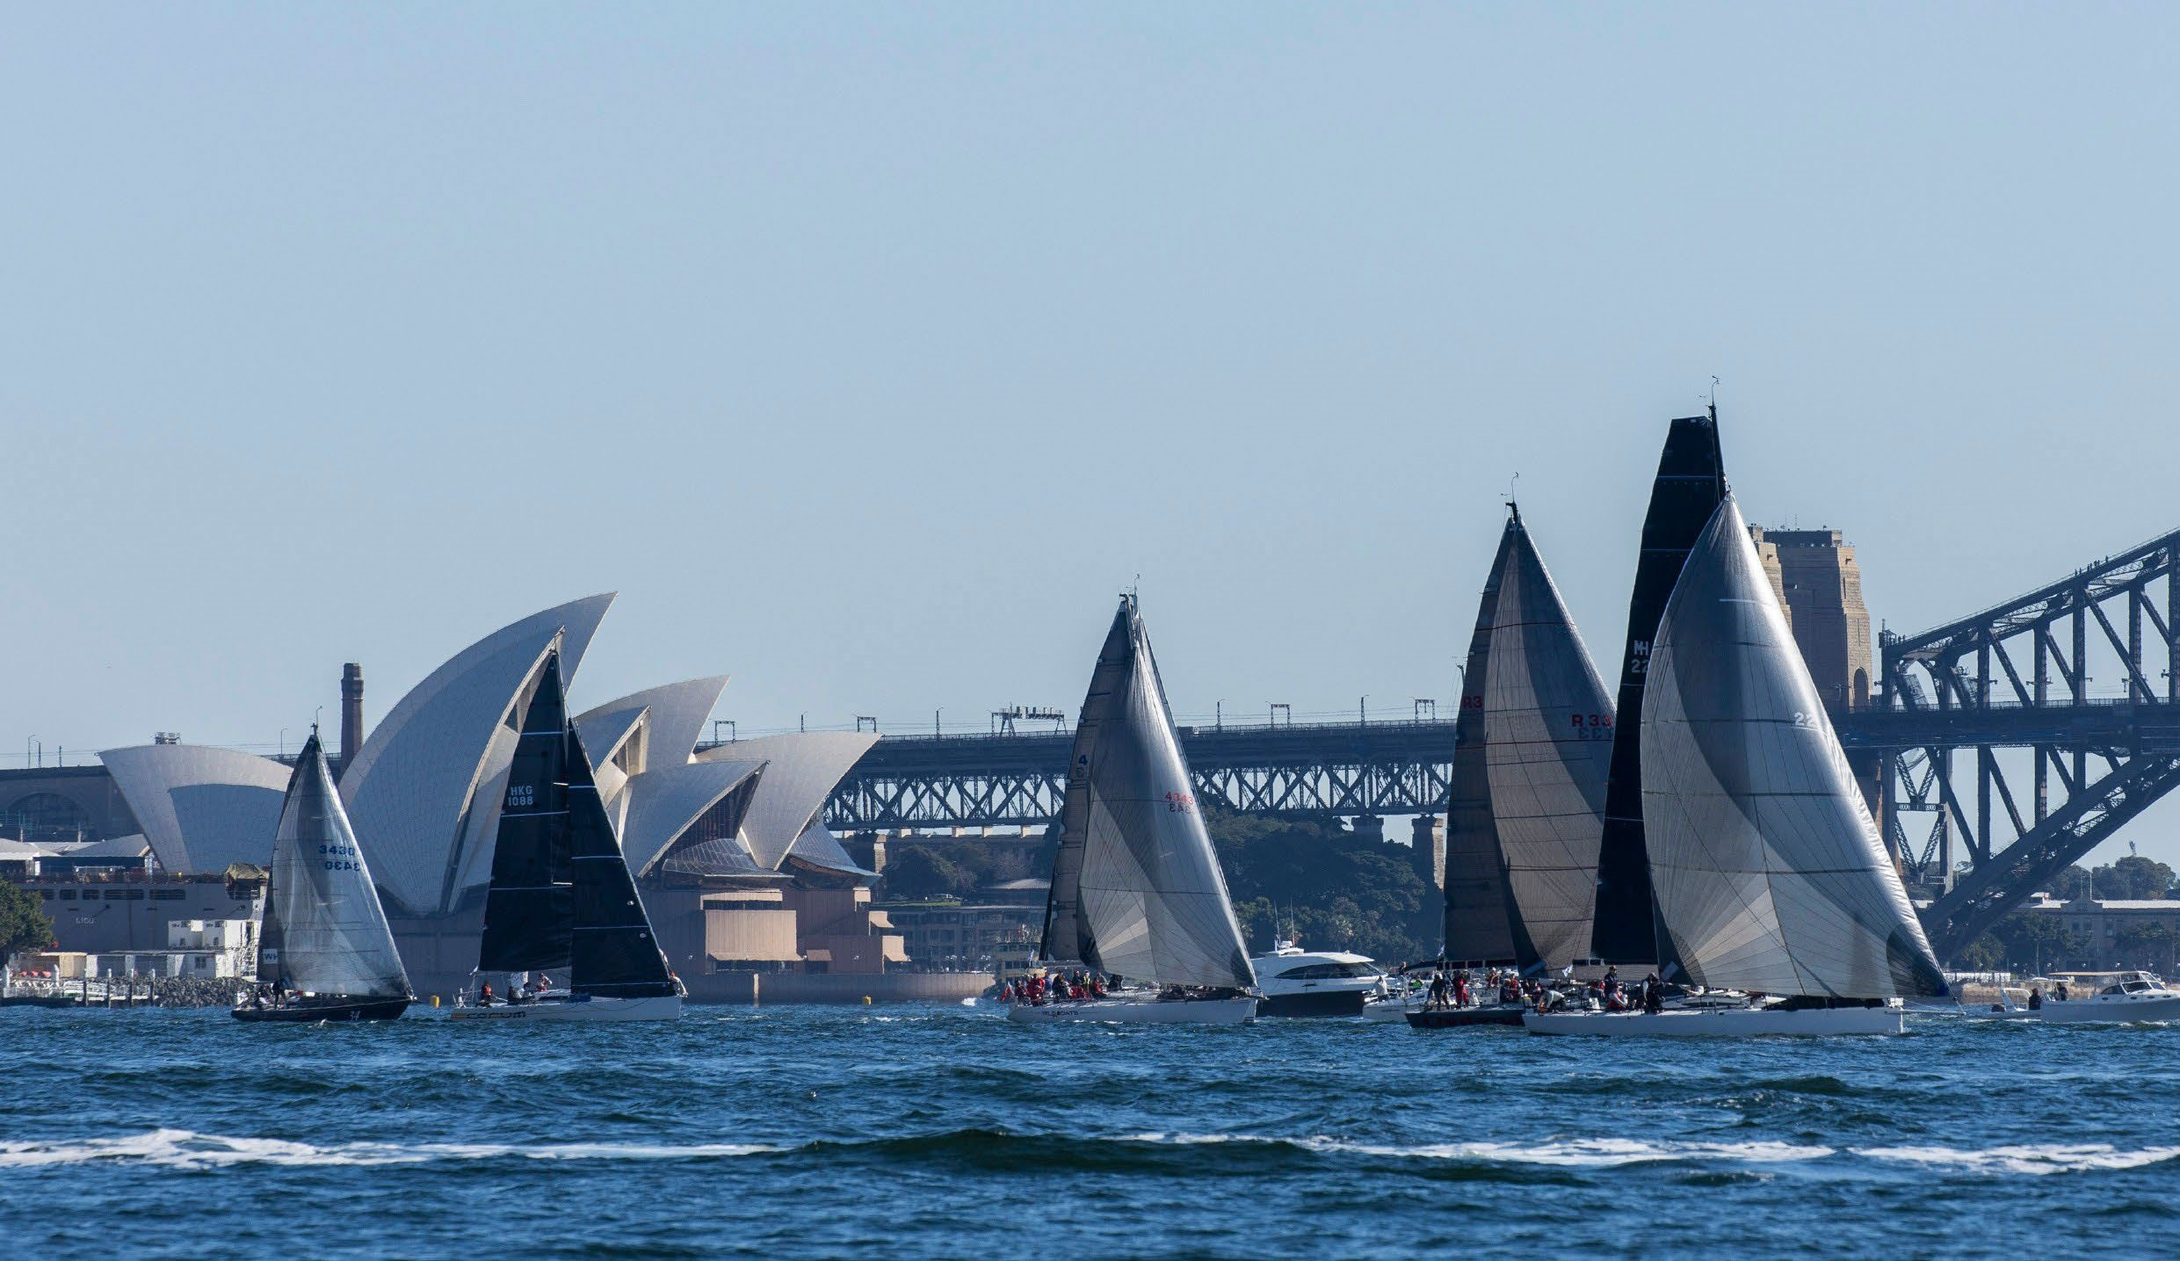

## A close up of a gold cup Description automatically generated 2.3. Official Notice Board

Prior to the starting signal the Official Notice Board is located on the ground floor of the SYC. Notices posted on the Official Notice Board may also be published on the race website.

## 2.4. Sailing Instructions

The Sailing Instructions will be issued at, and may be available prior to, the race briefing. The Sailing Instructions will also be published on the race website.

**2.5. National Jury**

The Organising Authority will appoint a National Jury for the race.

# 3. ELIGIBILITY

A boat must satisfy the following requirements in order to have its entry accepted:

**3.1. Boat:**

A boat shall:

1. be single hulled;
2. have a:
   1. Hull length (as defined in The Equipment Rules of sailing of World Sailing and referred to IRC as “LH” and ORC / IMS as “LOA”) of not more than 30.48 metres if entered as a fully crewed boat (NOR 3.4.1) and not more than 19.90 metres if entered as a two-handed boat (NOR 3.4.2); and
   2. Hull length of not less than 9.00 metres for all boats; and
   3. Waterline Length (as defined in the Equipment Rules of Sailing) not less than 7.3 metres for all boats.
3. comply with AS Special Regulations Part 1 for Race Category 2.

The Organising Authority highlights the following AS Special Regulations:

* 1. A boat must satisfy the stability criteria of the AS Special Regulations Part 1 Appendix B (extracts of which are included in Appendix B of this NoR);
  2. A boat must be built in accordance with the AS Special Regulations Part 1, Section 3.03.

The Organising Authority may elect to obtain technical advice as to a boat’s eligibility and the data and documentation supplied with regard to verification of stability, verification of construction and keel inspections, at the cost of the entrant concerned. The entrant will be consulted prior to this occurring.

## 3.2. Insurance

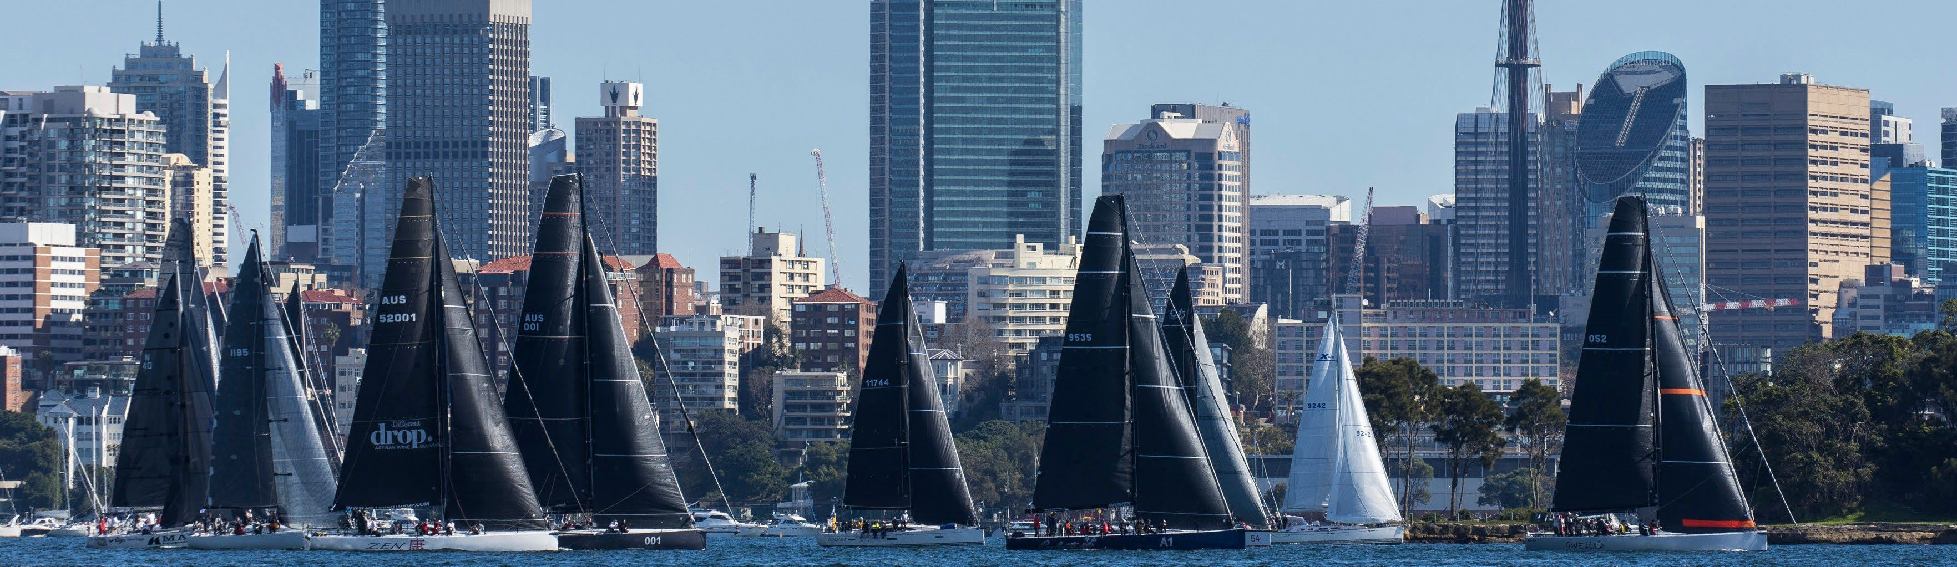The owner or charterer of a boat shall hold a marine legal liability insurance policy with respect to the boat current when racing, with a sum insured of not less than A$10 million (or such higher amount as the owner/charterer considers appropriate having regard to the size and type of boat, the number of crew and the conditions it may encounter during the race, or its equivalent in another currency). The insurance policy shall state that the boat is covered for the race or that it is covered for yacht races of a length greater than 384 nautical miles.

## 3.3. Handicap Categories/Class

1. A boat shall enter one of the following handicap categories:
   1. IRC Boats
      1. fully crewed boat (NOR 3.4.1) may only enter the IRC Handicap Category if the boat:
         * has a current, valid Endorsed IRC Certificate;
         * has been weighed on scales by a RORC or UNCL approved measurer or the boat’s weight is derived from an ORCi certificate or calculated by a Naval Architect (dispensation from weighing may be granted by the Race Committee if the boat weight is prohibitive of doing so).

A two-handed boat (NOR 3.4.2) may only enter the IRC Handicap Category if the boat:

* + - * has a current, valid Endorsed IRC Certificate;
      * has been weighed on scales by a RORC or UNCL approved measurer or the boat’s weight is derived from an ORCi certificate or calculated by a Naval Architect (dispensation from weighing may be granted by the Race Committee if the boat weight is prohibitive of doing so).
      * limits the output of their autopilot to the rotation of the boat’s stern rudder/(s).

All boats may additionally hold a secondary valid Endorsed IRC Certificate. Owners shall declare to the Organising Authority via email (sailingoffice@cyca.com.au) which of the primary or secondary certificate will be used prior to the rating deadline (NoR 4.1). If a boat does not declare which certificate by the deadline, the primary certificate will be used.

* 1. Performance Handicap (PHS) Boats

* + 1. fully crewed boat (NOR 3.4.1) that does not enter the IRC handicap category shall enter the Performance Handicap Category.

A two-handed boat (NOR 3.4.2) that does not enter the IRC handicap category or does not have an autopilot limited to the rotation only of the boat’s stern rudder(s) shall enter the Performance Handicap Category.

1. In addition to the Handicap Categories in NOR 3.3(a), a boat may enter one or more of the following:
   1. One Design Class Boats
      1. boat may only enter a One Design Class nominated by the Race Committee if the boat has a current, valid One Design Class Certificate for that class.
   2. IRC Corinthian Boats
      1. boat may only enter the IRC Corinthian Handicap Category if the boat is entered in IRC (NoR 3.3(a)(i)) and all crew meet the requirements of the World Sailing Sailor Classification for Group 1 (see World Sailing Regulation 22) and have a World Sailing Sailor ID.
   3. PHS Corinthian Boats
      1. boat may only enter the PHS Corinthian Handicap Category if all crew meet the requirements of the World Sailing Sailor Classification for Group 1 (see World Sailing Regulation 22) and have a World Sailing Sailor ID.
2. The Race Committee may create divisions within Handicap Categories and allocate boats to divisions within a Handicap Category at its sole discretion. The composition and allocation of boats into divisions shall not be subject to protest or grounds for a request for redress (amends RRS 60.1 and 62.1(a) and RRS 63.1 shall not apply).
3. The Race Committee’s determination as to whether a One Design Class will be accepted is final and binding. Boats that wish to nominate a One Design Class should do so in writing.

## 

## 3.4. Crew

### **3.4.1** Fully Crewed boats

1. A boat shall have a minimum of 5 crew.
2. The minimum age of all crew is 16, with a majority of the crew being of a minimum age of 18 years. Crew aged between 16 and 18 years must provide evidence to the Race Committee demonstrating past sailing experience. The Race Committee may, in its absolute discretion, refuse to allow any crew member aged between 16 and 18 years of age to participate in the race.
3. At least 50% of the crew shall have completed a Category 2 race or a passage that the Race Committee deems equivalent.
4. At least 30% of the crew shall hold a current certificate demonstrating that they have completed an Australian Sailing Safety and Sea Survival Course or an equivalent as noted on the following webpage: https:/[/www.sailingresources.org.au/training/sss-rpl/](http://www.sailingresources.org.au/training/sss-rpl/) (e) At least two crew members shall:
   1. be a practising medical practitioner; or
   2. hold a current Provide First Aid Certificate; or
   3. hold a First Aid qualification that the Race Committee considers is equivalent at least to NoR 3.4.1(e)(ii).
5. At least two crew members shall hold a Short-Range Marine Radio Operators Certificate of Proficiency (SROCP) issued by a relevant authority, or a higher qualification. It is recommended that at least two crew members hold a Long-Range Marine Radio Operators Certificate of Proficiency (LROCP).
6. It is recommended that the skipper or 2IC have a recognised Australian Sailing certificate (or equivalent) of at least an Offshore Skipper certification.

### **3.4.2** Two Handed boats

1. A boat shall have 2 crew.
2. The minimum age of all crew is 18.
3. At least one crew member shall have competed in a Category 4 or higher two-handed division or race in the last three years.
4. Both crew members shall have completed a Category 2 race or a passage that the Race Committee deems equivalent (fully crewed or two-handed).
5. Both crew members shall have completed a minimum 100nm two-handed race or passage (including overnight experience) together in the boat entered.
6. Both crew members shall hold a current certificate demonstrating that they have completed an Australian Sailing Safety and Sea Survival Course or a course noted on the following webpage: https:/[/www.sailingresources.org.au/training/sss-rpl/](http://www.sailingresources.org.au/training/sss-rpl/) (g) Both crew members shall:
   1. be a practising medical practitioner; or
   2. hold a current Provide First Aid Certificate; or
   3. hold a First Aid qualification that the Race Committee considers is equivalent at least to NoR 3.4.2(g)(ii).
7. Both crew members shall hold a Short-Range Marine Radio Operators Certificate of Proficiency (SROCP) issued by a relevant authority, or a higher qualification. It is recommended both crew members hold a Long-Range Marine Radio Operators Certificate of Proficiency (LROCP).
8. It is recommended that the skipper or 2IC have a recognised Australian Sailing certificate (or equivalent) of at least an Offshore Skipper certification.

**3.5. Documentation and Fees**

1. Initial Documentation - by 1700 hours on 7 July 2023
   1. boat shall complete the entry form (including the Conditions of Entry) through the online entry system - https://goldcoast.cycaracing.com/competitors/race-documents/ - by

1700 hours on 7 July 2023. If the current versions of the following are not already held by the Organising Authority, the following documentation shall be submitted:

* 1. verification of stability (refer NoR 3.1(c)(i) and Appendix B);
  2. verification of hull construction standards (refer NoR 3.1(c)(ii));
  3. current keel inspection certificate (refer Special Regulations 3.02.4 to 3.02.6);
  4. declaration of Crew Experience (through the Crew List in the online entry) (refer NoR 3.4);
  5. for a two-handed boat (3.4.2), the two-handed crew experience declaration as supplied by the Organising Authority; and
  6. a colour photograph of the boat under sail, no older than 12 months and suitable for search and rescue purposes. This shall be a digital photo with a resolution not less than 1200x800 pixels.

|  |
| --- |
| No entries will be accepted after this date. |

* 1. The boat is responsible to ensure that the initial documentation is received by the Organising Authority.

1. Final Documentation - by 1700 hours on 14 July 2023
   1. boat shall then ensure that the Organising Authority receives the following by 1700 hours on 14 July 2023:
   2. audited AS Special Regulations Equipment Audit Form for Category 2 or higher category Note: CYCA requires all audits be dated after 30 June 2023. A boat requiring an equipment audit at the CYCA should make a booking at the Sailing Office;
   3. inflatable lifejacket service certificates (AS Special Regulations 5.01.5 as supplemented by NoR 7.3(f));
   4. Life Raft Inspection Certificate(s) (AS Special Regulations 4.19.4(b));
   5. CYCA Radio Inspection Certificate (AS Special Regulation 3.25.3 as supplemented by NoR

7.3(c));

* 1. 406 EPIRB proof of registration (AS Special Regulations 4.18);
  2. Class, Measurement and Rating Certificates, as required (NoR 3.3);
  3. Certificate of Currency of Insurance, in English, with details of the cover and the insurer (NoR 3.2);
  4. Australian Sailing Safety and Sea Survival Course Certificates or acceptable equivalent (NoR 3.4);
  5. Medical Qualifications / First Aid Certificates (NoR 3.4);
  6. Short-Range Marine Radio Operators Certificates of Proficiency (SROCP) in Radio

Telephony or acceptable higher qualification (NoR 3.4);

* 1. for a boat entered in a One Design Class, the document(s) specified by the Organising Authority as contemplated by the One Design Rules and Regulations;
  2. crew list to be completed through the online entry;
  3. AIS MOB Declaration, as supplied by the Organising Authority;
  4. for a boat entered in a Corinthian Handicap Category, a Crew Declaration Form including each crew member’s World Sailing Sailor ID number and World Sailor Classification; and
  5. Disclaimer and Acknowledgment of Rights Form, signed by each crew member or, if the crew member is under the age of 18, the Disclaimer and Acknowledgement of Rights Form for minors, signed by the Parent/Guardian of the crew member (NOR 13). In each case the form is to be as supplied by the Organising Authority.
  6. The boat is responsible to ensure that the final documentation is received by the Organising Authority.

1. Entry Fees
   1. boat shall pay the following fees by 1700 hours on 14 July 2023:

|  |  |  |
| --- | --- | --- |
|  | CYCA Member | Not a CYCA Member |
| (i) Entry fee | A$783 | A$870 |
| (ii) PLUS the fee per crew member | A$67.50 | A$75 |
| (ii)PLUS the fee for each Handicap Category or One Design Class entered after the first  entry under NoR 3.3(a) | A$112.5 | A$125 |
| (iv) PLUS an additional fee may be charged to boats that have not complied with the  documentation and fee requirements by 14 July 2023 | A$400 | A$400 |

A rebate of half the entry fee (c(i)) will be paid in August 2023 if all documentation and fees have been received and paid by 1700 hours on 14 July 2023.

Note:

* + - All fees include Australian Goods and Services Tax (a tax invoice will be issued on request).
    - A surcharge will be applied when using a credit card.

1. A boat that withdraws prior to 1700 hours on 14 July 2023 that has paid the fees (3.5(c)) will be eligible for a full refund. A boat that withdraws between 15 July 2023 and 24 July 2023 that has paid the fees will be eligible for a refund, less an administrative fee of A$400. Any withdrawal after this date will not be eligible for a refund.
2. The Organising Authority may accept a request for an existing entry to replace the boat entered after the entry deadline (NoR 3.5 (b)) in the instance that the entered boat cannot be raced due to unintentional damage that cannot practically be repaired prior to the race, or otherwise due to circumstances beyond the control of the person or entity who entered the race. In deciding whether or not to accept such a request, the Organising Authority may require additional information or actions from the entry (such as a report from a Naval Architect). If such a request is accepted, deadlines detailed in the Notice of Race may be amended for the particular request. The Organising Authority has an absolute discretion to accept such a request and the decision of the Organising Authority in this regard is final and binding and will not be grounds for a request for redress or protest (amends RRS 60.1 and 62.1(a)).

**In accordance with RRS 76.1, the entry of a boat that does not comply with the conditions of this Notice of Race will be rejected or cancelled.**

7

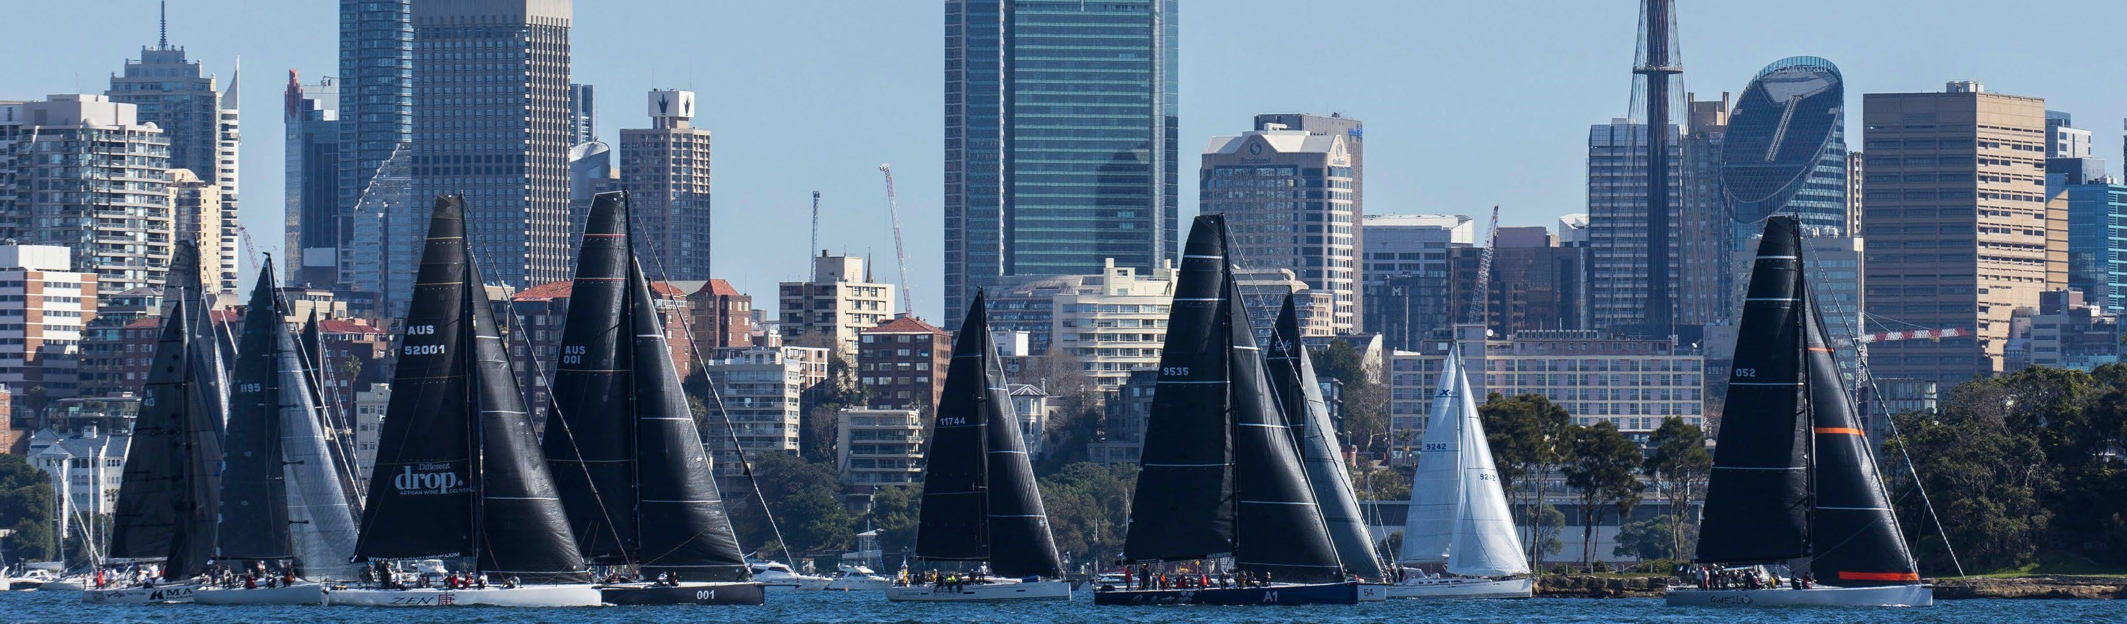

## 3.6. Briefings

A boat shall satisfy the following briefing requirements:

1. Compulsory Race Briefing
   1. compulsory race briefing will be held on 27 July 2023 at 1800 hours at the CYCA and also online by webinar (link to be provided).

Two crew members, who are any of the Owner (if the Owner is a member of the crew), Skipper, Second in Command (2IC) or Navigator, shall attend at the CYCA or register and view the whole of the race briefing online. Any crew members who attend the briefing via Webinar shall lodge the race briefing declaration (https://cycaforms.seamlessdocs.com/f/ GoldCoast2023), confirming attendance by 1700 hours on 28 July 2023.

1. Compulsory Weather Briefing
   1. compulsory weather briefing will be held on 29 July 2023 at 0800 hours at the CYCA and also online by webinar (link to be provided).

At least one crew member of a boat intending to compete in the race shall attend at the CYCA or register and view the whole of the weather briefing online. It is mandatory that one of the Skipper or the Navigator attend. Any crew member who attends the briefing via Webinar shall lodge the weather briefing declaration (https://cycaforms.seamlessdocs.com/f/ GoldCoastWeather2023), confirming attendance by 1100 hours on 29 July 2023.

# 4. CHANGES TO SUPPLIED DOCUMENTATION

**4.1. The Race Committee will not** accept a change to a boat’s IRC certificate or a change in declaration for a primary or secondary IRC Certificate after 1900 hours on 21 July 2023 except as a result of a rating protest or to correct a rating office error.

**4.2. A boat shall promptly inform the Race Committee** of any change to documentation required in NoR 3.5(a) and (b).

**4.3. The Race Committee may** accept changes to documentation required in NoR 3.5(a) and (b) after the required lodgement date, subject to any conditions that the Race Committee may impose.

**4.4.** A boat’s crew list may be changed after 14 July 2023 to correct errors or to amend for late crew changes but shall not be changed later than three hours prior to the starting signal. After any change to a crew list, the boat shall still satisfy the general requirements of paragraph 3.4.

# 5. DETERMINATION OF ELIGIBILITY

A decision of the Organising Authority or the Race Committee as to any matter under NoR 3, including as to whether a boat and her crew meet the eligibility criteria for entry in the race, is final and binding and will not be grounds for a request for redress (amends RRS 60.1 and 62.1(a) and RRS 63.1 shall not apply).

# 6. SCORING

**6.1.** Overall Winner

The overall winner of the Maritimo Gold Coast Mackay Yacht Race 2024 will be the boat that wins the overall IRC Handicap Category.

**6.2.** Line Honours

A boat that enters the race will be scored in a handicap category as well as the Line Honours category. No boat will be scored only for Line Honours. The Line Honours winner of the Maritimo Gold Coast Mackay Yacht Race 2024 will be the boat that wins the Line Honours Category.

**6.3.** All scoring

1. Scoring penalties will be applied when determining a score. A boat subject to a scoring penalty is not eligible for a race record.
2. Time penalties will be applied when determining a score, elapsed time or race record.
3. Redress will be applied when determining a score, elapsed time or race record.
4. Boats scored in a division of the IRC Handicap Category will also be scored in the overall IRC Handicap Category result.

* 1. Line Honours results

Subject to NoR 6.3, the boat with the lowest elapsed time shall be scored first in the Line Honours Category and other boats shall be ranked accordingly.

* 1. IRC (IRC Handicap Category, IRC Corinthian, and Divisions of them)

1. Results will be calculated by the application of the IRC Time Corrector (TCC) as a multiplier of elapsed time.
2. Subject to NoR 6.3, the boat with the lowest corrected time will be scored first and other boats shall be ranked accordingly.

**6.6.** PHS Divisions

1. Results will be calculated by the application of Time Correction Factors (TCFs) as a multiplier of elapsed time.
2. A boat’s TCF will be determined by the Race Committee or its nominee. The determination of the TCF will not be subject to protest or redress (amends RRS 60.1 and 62.1(a) and RRS 63.1 shall not apply).
3. Subject to NoR 6.3, the boat with the lowest corrected time will be scored first and other boats shall be ranked accordingly.

* 1. One Design Class

Subject to NoR 6.3, the boat with the lowest elapsed time will be scored first and other boats shall be ranked accordingly.

* 1. Scoring Penalties

Scoring penalties will be applied as set out in the Sailing Instructions for a breach of RRS Rule 2 outside Sydney Harbour and may be applied at the discretion of the International Jury for other breaches of the rules or by the Race Committee in circumstances set out in the Sailing Instructions.

# 7. CHANGES TO RATING SYSTEM RULES AND RRS AND ADDITIONS TO AS SPECIAL REGULATIONS

**7.1.** Changes to the IRC Rules

1. IRC Rule 21.1.5(e): A spare mainsail may be carried as a bona fide replacement for a mainsail damaged during the race.
2. IRC Rules 11.2 & 21.6.1: In accordance with a prescription by Australian Sailing, a boat in the IRC Handicap Category may carry one more spinnaker than shown on the boat’s IRC Certificate without an increase of rating.
3. IRC Rule 15.1 is deleted. Refer NOR 7.2 (d).
4. IRC Rule 15.2 (d) is amended to: A fully crewed boat (NoR 3.4.1) shall not use stored power for steering.

**7.2.** Changes to the Racing Rules of Sailing (a) Add the following to RRS 41:

1. Whilst racing, a boat may retrieve data from any page of the race website, details of which are provided in the Sailing Instructions, even if that page is not publicly available. During the race, a boat shall not contact, or be in contact with, any person or private entity using any medium to receive private meteorological forecasts, tactical advice or information customised for a particular boat or group of boats. A boat may, however, obtain assistance in the form of any readily available commercial meteorological or hydrographical information regardless of cost.
2. A boat may receive assistance in ensuring that satellite or cellular communication systems on board are able to transmit and receive data.
3. RRS 44: Alternative penalties may be changed in the Sailing Instructions and may include different penalties for infringements just after the start compared to penalties for infringements in the rest of the race.
4. RRS 51: Only those boats whose Rating Certificate(s) have been computed taking into consideration variable ballast are allowed to move this and only this ballast. All other moveable ballast shall be properly stowed.
5. RRS 52: RRS 52 is changed for fully crewed boats (NOR 3.4.1) to: The rotation of a boat’s rudder shall be adjusted and operated only by the power provided by the crew.

RRS 52 does not apply to a two-handed boat (NoR 3.4.2).

1. RRS 61.3: There is no time limit on protests by the Race Committee or the National Jury.
2. RRS 64.2: The National Jury may apply a scoring or time penalty in lieu of disqualification for an infringement of a rule.
3. RRS 78.2: A valid rating system or class certificate shall be produced by the due date specified (NoR 3.5(b)).
4. RRS Appendix G: An Australian boat chartered or borrowed by an international entrant may carry on the mainsail the national letters of the country represented but may have local sail numbers on other sails.

The Race Committee may include other changes to the RRS in the Sailing Instructions.

**7.3.** Additions to AS Special Regulations

Below are additional requirements to the AS Special Regulations:

1. Special Regulation 3.24.5(c): The minimum amount of engine fuel that shall be carried at the start of the race shall be at least Litres = LWL(metres)/0.2
2. Special Regulation 3.25.1: VHF Radio shall be the primary means of communication.

A boat shall carry a satellite phone on board (refer AS Special Regulation 3.25.1 (a)(ii). A boat shall be recorded as having sent a text message from the boat satphone to Race Control on +61 408 566 696 between 21 and 27 July 2023: “This is boat name xxxxx NSGCYR 2023”. Boats not recorded as having sent such a text will not be eligible to start the race.

1. Special Regulation 3.25.3(b): A boat shall provide a CYCA Radio Inspection Certificate with the pre-start documentation where a current certificate is not already held by the Organising Authority. The CYCA Radio Inspection Certificate is to be completed by an accredited radio technician to verify the adequacy of the installation and operation of the radios.
2. Special Regulation 3.29.1: An AIS Transponder shall be carried and be switched on, such that it is receiving and transmitting at regular intervals (no less than 5 minutes) for the duration of the race. The failure of any station to receive a signal from a boat’s AIS Transponder shall not be subject to protest or grounds for redress (amends RRS 60.1 and 62.1(a) and RRS 63.1 shall not apply).
3. Special Regulation 5.01.1(h): A lifejacket shall be worn by each member of the crew at, but not limited to, these times:
   1. When on deck between the hours of sunset and sunrise
   2. When alone on deck
   3. When on deck when the true wind speed is 25 knots or above
   4. When on deck when visibility is less than 1 nautical mile.
4. Special Regulation 5.01.5: Each inflatable lifejacket shall be checked and serviced at the intervals as prescribed by the manufacturer by an authorised servicing agent and documented evidence of that servicing submitted as part of the entry documentation.
5. A two-handed boat shall be fitted with an autopilot.

# 8. PAPER CHARTS/BOOKS

A boat shall carry the charts, in paper or electronic form, listed in Appendix A (refer AS Special Regulation 4.10).

# 9. MEASUREMENT AND INSPECTION

**9.1.** A boat shall permit a representative of the Race Committee to conduct spot inspections, if so requested by the Race Committee. Spot checks may be carried out prior to the warning signal or after a boat finishes or retires.

**9.2.** The Race Committee may require re-measurement of any boat. If this is done separately to a protest or redress hearing, then the costs of such re-measurement shall be the responsibility of the boat.

# 10. EVENT ADVERTISING

A boat shall display the sponsor’s backstay flag from 0700 hours on 29 July 2023 until 1100 hours on 1 August 2023.

# 11. TRACKING DEVICES AND CAMERAS

**11.1.** A boat shall carry a tracking device if so required by the Organising Authority. The device will be supplied by the Organising Authority. Once supplied, the tracking device becomes the responsibility of the Owner. Loss, damage or failure to return the tracking device will incur a £650 charge (to be charged in AUD at the exchange rate at the time). A boat on which such unit fails or ceases to operate may be required to provide additional position reports by radio/satphone in accordance with the Sailing Instructions.

**11.2.** A boat shall carry a camera or telemetry equipment if so required by the Organising Authority. The camera or equipment will be supplied by the Organising Authority.

# 12. MEDIA RIGHTS AND RESTRICTIONS

**12.1.** The Organising Authority owns:

* all media rights to the Maritimo Gold Coast Mackay Yacht Race 2024; and
* all rights in and to any visual and audio material and any data taken or collected by or on behalf of the Organising Authority, or provided to it, in connection with the race.

The Organising Authority may exercise and exploit those rights as it sees fit.

* 1. The owner or charterer of the boat and all crew members or, in the case of a crew member under the age of 18 years, a parent or guardian, shall grant the Organising Authority and Noakes Group the unconditional, perpetual right and authority to publish and broadcast anywhere in the world, for any purpose and in any medium, the names, images, data and biographical information of the crew and still and moving images and audio recordings of the boat and its crew prior to, during and after the race. The use of images and video and audio content of crew members under the age of 18 years is subject to the granting of permission to do so by a parent or guardian.
  2. A boat shall not use any form of positioning or telemetry system, other than that supplied or authorised by the Organising Authority, to post or broadcast the boat’s position or other boat data to any media organisation or on any internet site or social media.
  3. Crew members of a boat may speak to accredited members of any media organisation prior to, during and after the race, regarding the boat, the race and the prospects, performance or strategy of boats entered or participating in the race, subject to:

1. any comments not undermining or interfering with, or having a detrimental impact on, the Organising Authority and its officers, employees, volunteers and members, the Race

Committee, the National Jury, measurers, Noakes Group or any other sponsor or supporter of the Organising Authority;

1. no reference being made during such a commentary to boats in distress or wreckage sightings; and
2. all information given being accurate (for example, no deliberately false sightings or positions may be reported).

**12.5.** A boat and its crew may publish on a live or delayed basis (including by streaming to an internet site or on social media) still and moving images and audio material taken on or from the boat subject to:

1. no such material being published in any medium during the period from 20 minutes prior to the warning signal to one hour after the starting signal;
2. no such material being published which contains images of or refers to a boat in distress or wreckage without the prior approval of the Organising Authority; and
3. copies of any recorded material, such as video or film tapes of any interviews and video footage obtained on the boat (whether or not transmitted from the boat), being provided to the Organising Authority by 10 August 2023 together with a perpetual licence to use and exhibit the material for any purpose anywhere in the world, unless otherwise agreed by the Organising Authority.
   1. The approvals in NoR 12.4 and 12.5 may be revoked by the Organising Authority at any time with respect to any boat or any accredited media.
   2. A boat may during its race use a drone flown from and recovered by the boat in accordance with the Sailing Instructions.

# 13. DISCLAIMER

**13.1.** All those taking part in the race do so at their own risk and responsibility. Crew members or, if the crew member is under the age of 18 years, a parent or guardian, shall acknowledge this, release the Organising Authority, Noakes Group and any other sponsor of the Maritimo Gold Coast Mackay Yacht Race 2024 and their respective officers, employees, volunteers and members, from all liability and grant the rights referred to in NoR 12.2 by signing a Disclaimer and Acknowledgment of Rights Form, as supplied by the Organising Authority.

**13.2.** Specific attention is drawn to RRS Fundamental Rule 3 (Decision to race), which states:

*“The responsibility for a boat’s decision to participate in a race or to continue racing is hers alone”.*

**13.3.** By taking part in this race, each competitor agrees and acknowledges that they are responsible for complying with any regulations in force from time to time in respect of COVID-19 and for complying

with CYCA COVID-19 protocols and New South Wales Government’s and Queensland Government’s COVID-19 regulations or requirements.

# 14. PRIZES / TROPHIES

**14.1.** Trophies and prizes will be awarded as appropriate to the number of Handicap Categories and Divisions.

**14.2.** The trophy presentation will be held at the Southport Yacht Club. The date and time of the presentation will be advised at the completion of the race.

# APPENDIX A - CHARTS

# Charts

The following charts shall be carried on board (in paper or electronic form):

* AUS 809 - Port Jackson to Port Stephens
* AUS 810 - Port Stephens to Crowdy Head
* AUS 811 - Crowdy Head to Smoky Cape
* AUS 812 - Smoky Cape to Clarence River
* AUS 813 - Clarence River to Danger Point
* AUS 814 - Point Danger to Cape Moreton

A boat carrying electronic charts shall refer to AS Special Regulation 4.10.1(e).

# APPENDIX B – STABILITY REQUIREMENTS General

The requirements specified in this appendix apply to all boats intending to enter regardless of the handicap category in which they intend to enter.

**Competitors found to be falsifying documentation, deliberately invalidating certificates or otherwise misleading the Race Committee with regard to stability of their boat are subject to action under RRS 69.1. If found guilty the penalty could include disqualification from the Maritimo Gold Coast Mackay Yacht Race 2024 2023. The incident would also be reported to Australian Sailing.**

A determination by the Organising Authority or the Race Committee as to the suitability of supplied documentation in demonstrating a boat’s compliance with the stability requirements, as to whether there is a satisfactory margin as required by this appendix or as to a boat’s compliance with the stability requirements is final and binding.

# Non-Moveable Variable Ballast Boats

A boat shall provide evidence as follows to demonstrate that it achieves not less than:

* an ORCI Stability Index of 110 for the configuration in which the boat proposes to race; or
* International Standard ISO 12217 – 2 Design Category A except that the angle of vanishing stability (AVS) shall be a minimum of 115 (The OA may elect to obtain technical advice as to a boat’s eligibility and the data and documentation supplied, at the cost of the entrant concerned. This may include having measurements redone and documentation reproduced by another Naval Architect).

# Moveable Variable Ballast Boats

A boat shall provide evidence as follows to demonstrate that it achieves not less than:

* an ORCI Stability Index of 110 and a Ballast Leeward Recovery Index of 0.9 for the configuration in which the boat proposes to race; or
* International Standard ISO 12217 – 2 Design Category A and a Knockdown Recovery Factor of minimum 0.9 (The OA may elect to obtain technical advice as to a boat’s eligibility and the data and documentation supplied, at the cost of the entrant concerned. This may include having measurements redone and documentation reproduced by another Naval Architect).

**Further Requirements:**

Boats holding a current, valid ORCi Certificate

A boat with a current, valid ORCi Certificate shall supply that certificate, including the Stability and Hydrostatics Datasheet, accompanied by a completed Stability Declaration as supplied by the Organising Authority.

Boats previously holding a valid ORCi Certificate

A boat without a current valid ORCi Certificate but with a previously valid (but not current) certificate shall supply its most recent previously valid (but not current) certificate, including the Stability and Hydrostatic Datasheet, accompanied by a completed Stability Declaration supplied by the Organising Authority.

Boat achieving ISO 12217-2 Design Category A In the calculation of the stability data:

* The hydrostatics and stability demonstrating the yacht’s compliance with ISO Category A shall be derived from measurement of the freeboards and righting moment of the actual yacht by a qualified source (ie an inclination test)
* Deck and other enclosed volume above the sheer line may be taken into account, in which case offsetting cockpit volume shall also be taken into account.
* Mass shall be taken as Minimum Operating Mass as defined by ISO 12217-2, paragraph 3.5.3
* A GZ curve shall be submitted as part of the ISO statement

All boats

Other than in the case of a boat that submits a current, valid ORCi Certificate, the Organising Authority may elect to obtain technical advice as to a boat’s eligibility and the data and documentation supplied at the cost of the entrant concerned. The entrant will be consulted prior to this occurring.

